Name: Aman Sharma
Email: amankhandelwal047@gmail.com
Subject: Assignment work of AWS Essentials Batch-1, Day-4

Project – 3

Linux1 instance created

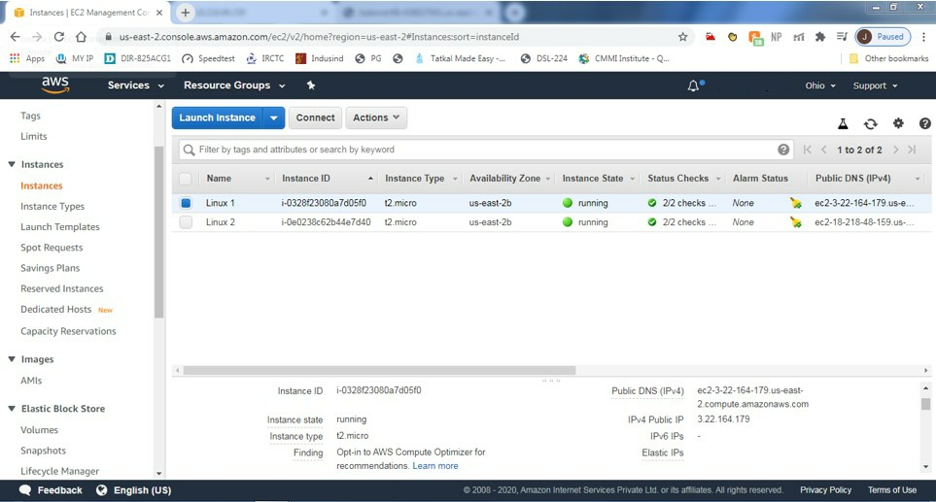

Linux2 instance created

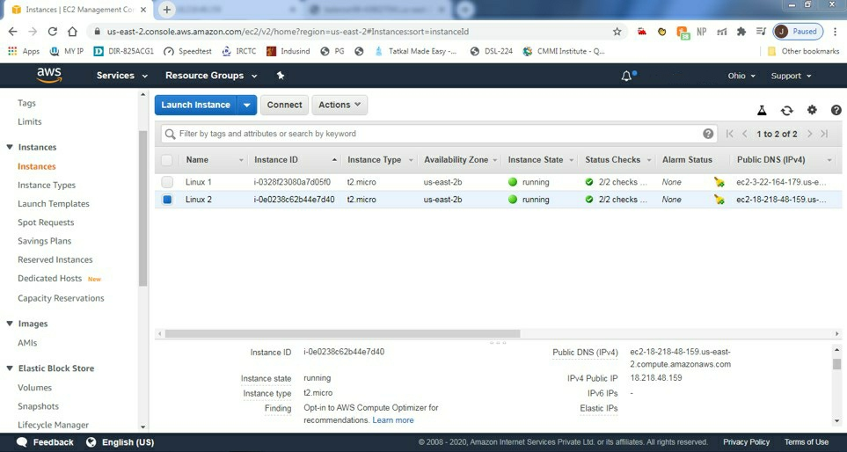

Linux 1- Server up webpage

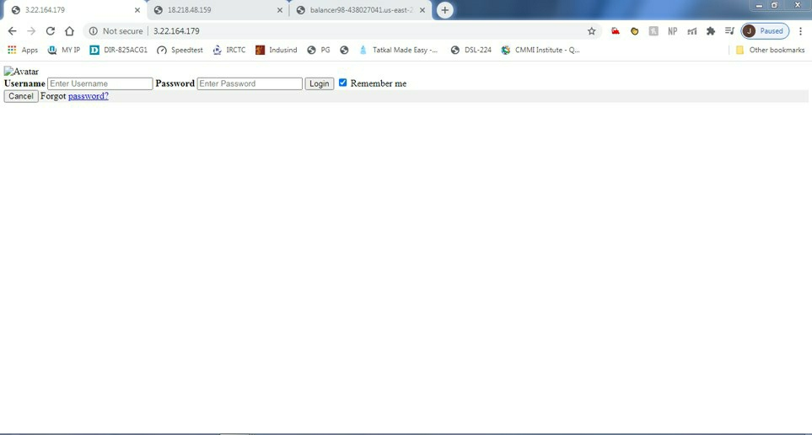

Linux 2- Server up webpage

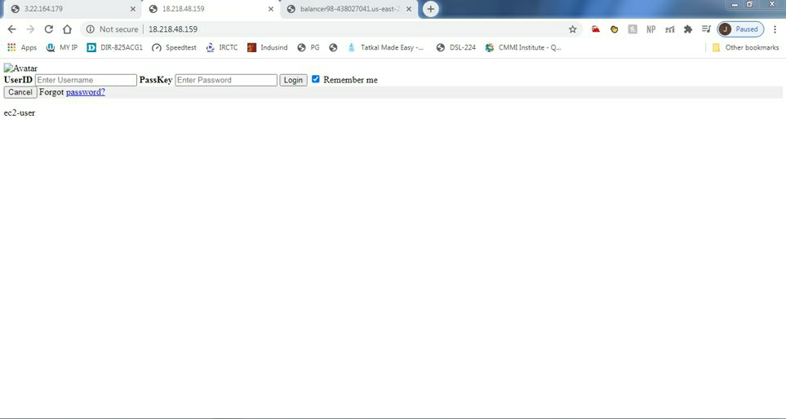

Load Balancer - DNS Name

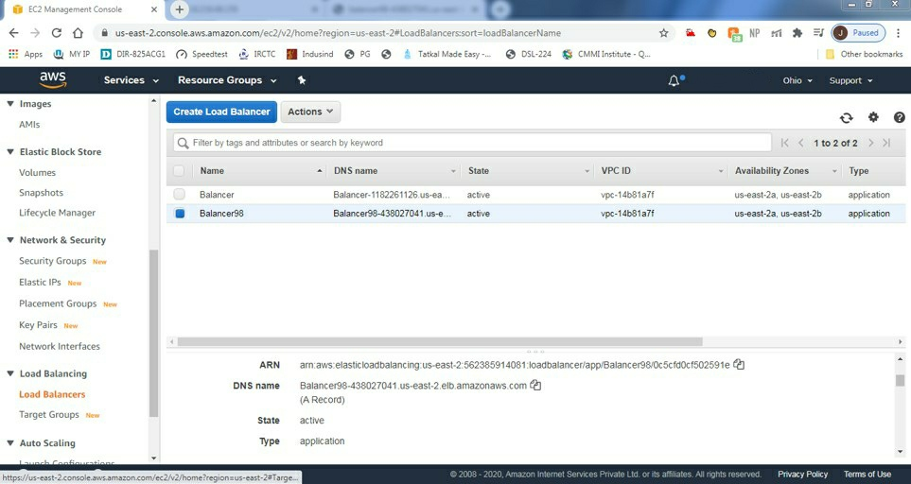

ELB responding html pages as below

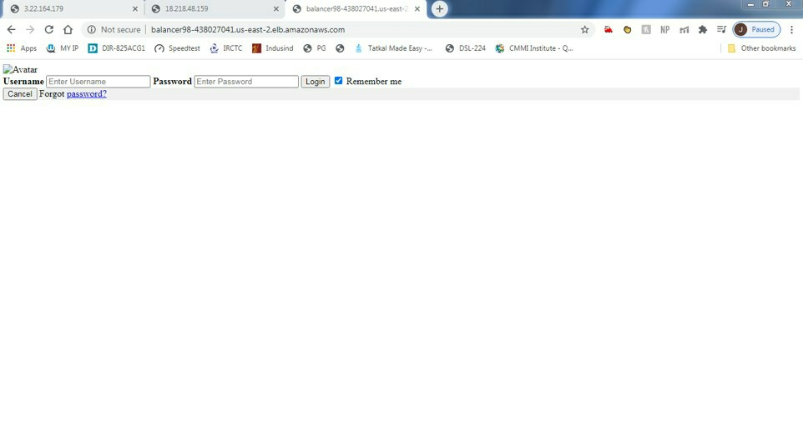

Thank You.

